**Amazon SNS Notification API Document**

**Database Details:**

DB: INEXTDB

Password: inextpwd

**Table Details:**

**AWS_SNS_DEVICE_REGISTER** – [The tables contains all the device id details].

**AWS_SNS_APPLICATION_TRACKER** – [The tables contains application tracker details. It means amazon response while creating application].

**AWS_SNS_PLATFORM_TRACKER** – [The tables contains platform end point details]

**AWS_SNS_APPLICATION_DETAILS** – [The tables contains application credentials details].

**Possible Issues:**

* Device ID/Application name already exist.
* Platform end point disabled.
* Mismatched credentials.

**Solution:**

1. Device ID/name already exist**.**

* Check the “AWS_SNS_DEVICE_REGISTER” if you found mismatched values delete the particular row and again reopen the application**.**

**Sample Query:**

1. SELECT * FROM AWS_SNS_DEVICE_REGISTER WHERE SNS_DEVICE_ID= "6004940982c67cff53efd2b7ea6b0c4a2f17af21ee0129dc241cfba373c1d177";
2. SELECT * FROM AWS_SNS_DEVICE_REGISTER WHERE SNS_DEVICE_APP_NAME = "Wellness";
3. DELETE FROM AWS_SNS_DEVICE_REGISTER WHERE SNS_DEVICE_APP_NAME = "Wellness";
4. Platform end point disabled:

Solution:

1. Please delete the particular application from “AWS_SNS_PLATFORM_TRACKER” and “AWS_SNS_APPLICATION_TRACKER”
2. Please login the following URL.

* <https://aws.amazon.com/console/>
* Using this [shyamsundar.nagarajan@cognizant.com](mailto:shyamsundar.nagarajan@cognizant.com) and “A$$0c1at#”.

Step1: Click SNS Tab (marked in Red color).

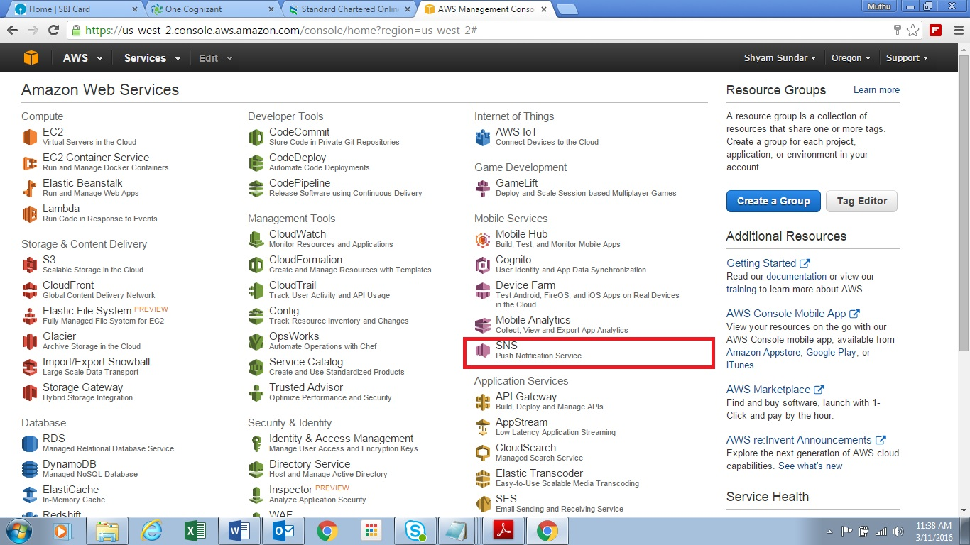

Step2: This SNS console click the Application Tab. Its show registered application details (marked in red color).

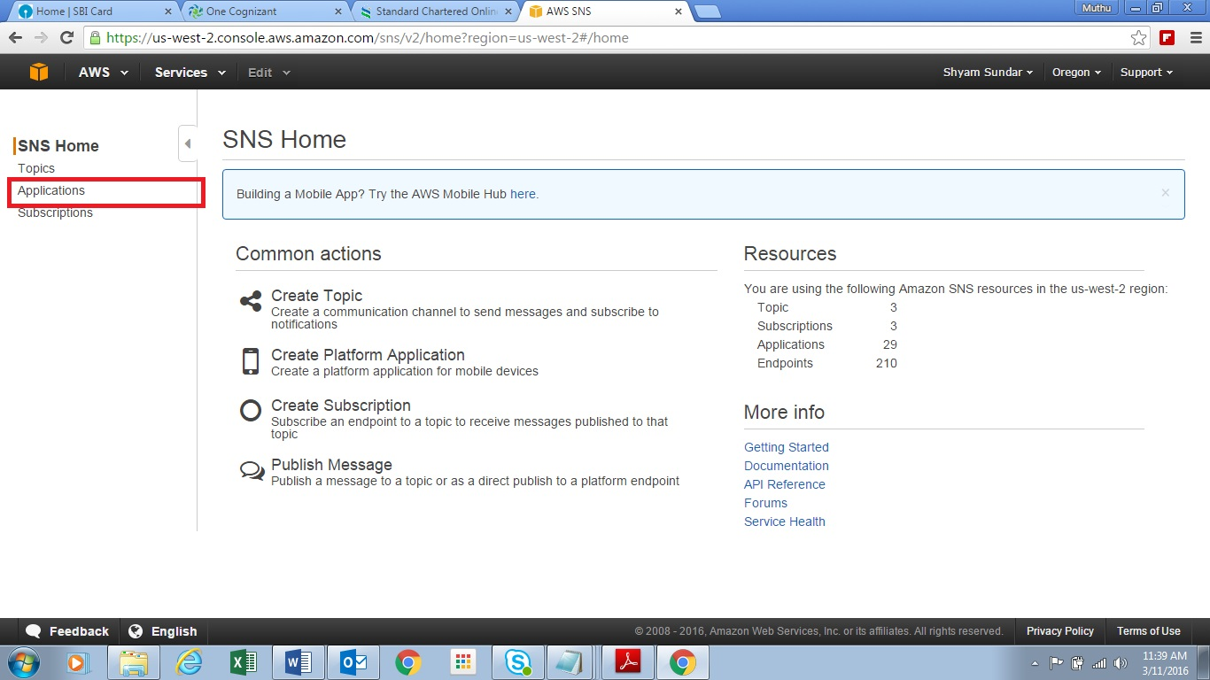

Step3: its list out registered application details. If you click the particular application, it will list out the end points for particular application. If you want to delete the particular application check particular application and click action tab. It have option delete click that and delete your application.

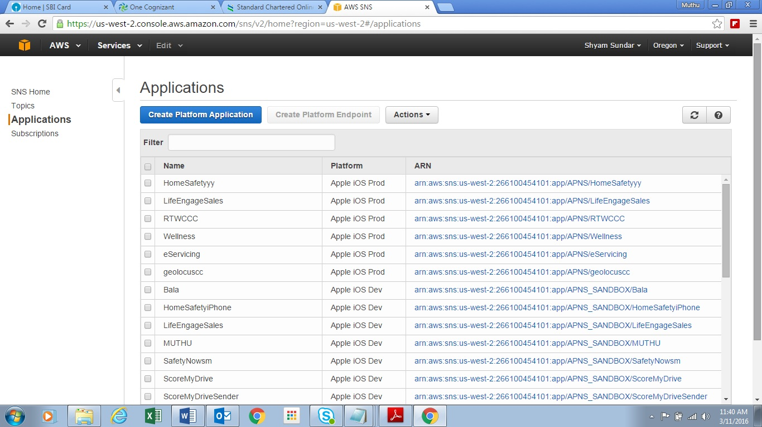

Step4: List out the end points details for particular application. If the endpoint enabled state false delete the end points and try it again. Make sure before that you have cleared the particular application details which I mentioned tables.

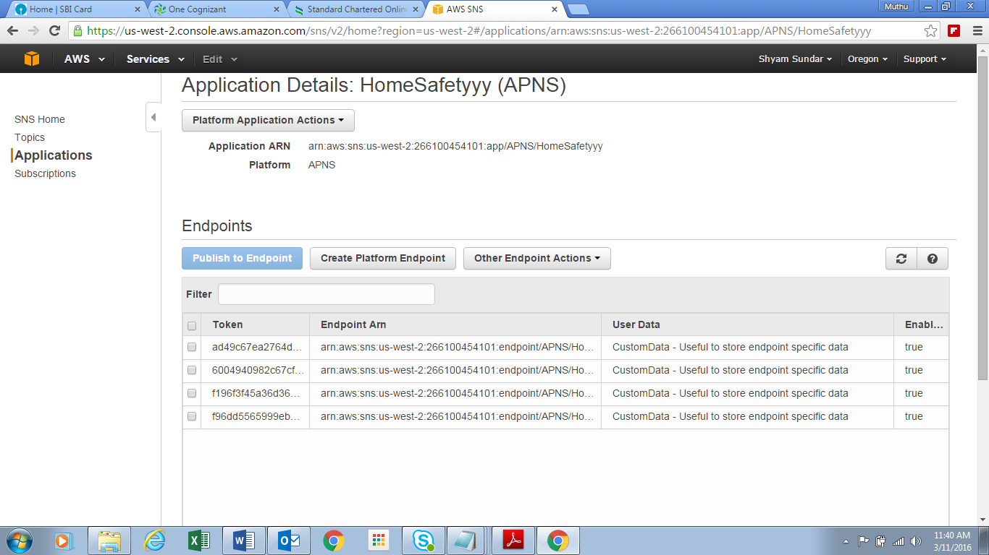

Sample Queries:

1. SELECT * FROM AWS_SNS_APPLICATION_DETAILS WHERE sns_application_name ="WindShieldd";
2. SELECT * FROM AWS_SNS_PLATFORM_TRACKER WHERE SNS_PLATFORM_APP_NAME = "WindShieldd";
3. DELETE FROM AWS_SNS_APPLICATION_TRACKER WHERE sns_application_name = "WindShieldd";

**PS: Before you are login to the AWS portal get approve from Shyam. There is an option to create new application and test your application manually.**

**Device Registration:**

URL: <http://104.196.43.212/Awsservices/Mobilepush>

Parameters:

* device_ids [it’s a unique Id for each device].
* Platform [it’s specify the push type based on the Mobile OS version.].

1. APNS, APNS_SANDBOX for Apple notification.
2. GCM for Android notification.

* app_name [its specify the application name].

**Application Registration:**

URL: <http://104.196.43.212/Awsservices/>

This web page used to register your app notification credentials details either IOS OR Android.

Apple Registration:

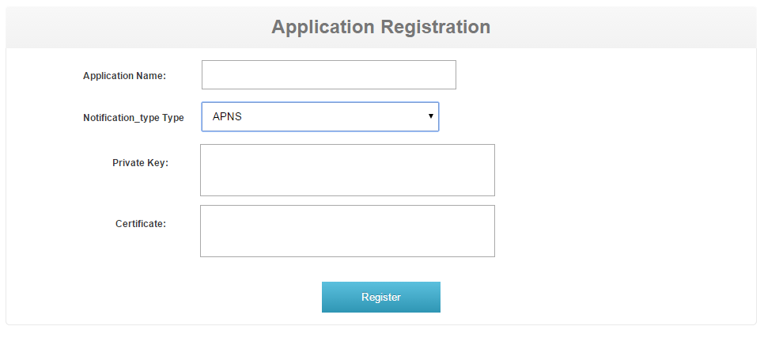

Android Registration:

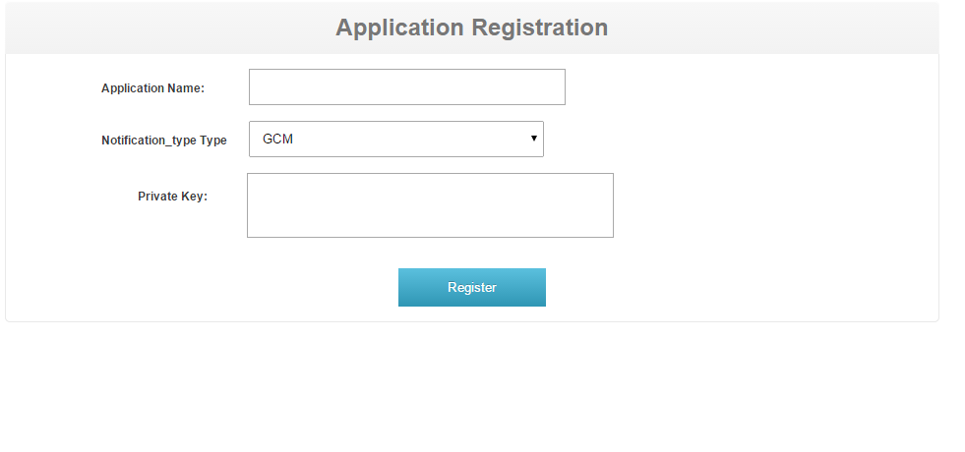

**Notification Push Services From the Web :**

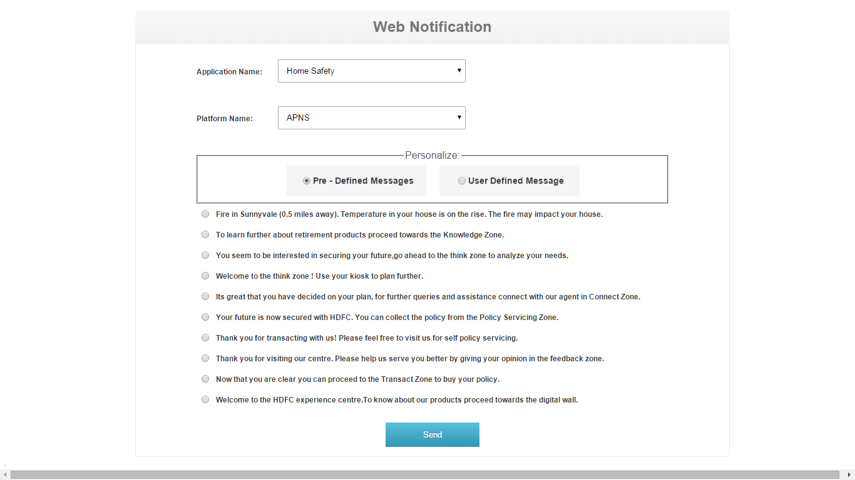

The Web page used to send the notification to the particular application. It’s either predefined message or user defined message. If you want predefined message generate XML file to the following format and move to your web application project.



**Notification pushing services:**

URL:  [http://104.196.43.212/Awsservices/services/awsservice](http://54.164.71.138/Awsservices/services/awsservice)

Parameters:

1. message [ its specify the Notification text ].
2. app_name [its specify the application name ].
3. service_name [its specify the service invoker name].
4. push_type [its specify the type of protocol SMS,email…]
5. topic_create [its specify topic creation. If you want the topic creation specifies the value 1.]
6. topic_title [specify the topic title].
7. end_pont_arn [ Based on the push type selection. you will give value according to that]
8. platform_type [ Its specify the Platform type either APNS,GCM,APNS_SANDBOX]

**Topic Creation AND Subscription**.

**Topic Creation:**

URL: <http://104.196.43.212/Awsservices/TopicCreation>

Parameters:

1. topic_name.

**Topic Subscriber:**

URL: <http://104.196.43.212/Awsservices/Subscriber>

Parameters:

1.topic_name.

2.app_name.

3.protocol_type.

**Topic Unsubscribe:**

URL: <http://104.196.43.212/Awsservices/UnSubscriber>

Parameters:

1.app_name.

2.topic_name.

**Reference Link:**

<http://docs.aws.amazon.com/AWSJavaSDK/latest/javadoc/com/amazonaws/services/sns/AmazonSNSClient.html>